Shaalin Jaiswal – CSE 205 Honors Contract – 4/30/2026
- Project Description:
As a premed student with an interest in medical imaging, I explored non-invasive techniques without the use of radiotracers or chemical injections as inspiration for a potential honors contract project. The MRI system was extremely interesting to me, and as I am minoring in biochemistry, I wanted to learn more about this portion of MRI data interpretation as it relates to biochemistry. With future technological advancements in mind, the capabilities of the MRI machine will only increase, allowing for a wealth of data to be interpreted and translated to usable information. These technological advancements will result in the mapping of abnormal biomarkers; the biochemical characteristics of tissues used as an indicator of health.
I enjoyed this project and scope-crept my way to building a primitive hospital simulator. This system allows the user to procedurally generate patients, automatically flag abnormalities based on four different medical scans with differing abnormality requirements, and treat patients by order of severity as determined by the triage’s weightages on different characteristics of each patient. I will describe the chain of events each user input command does to further illustrate how this system works.
Initialization. Enter Treatment Rooms: Generates treatment rooms for each type of scan in the system (Neuro, Pelvic, Ortho (Musculoskeletal), Trauma (Torso)). The initializeRooms() method in TriageSystem then adds the number of rooms specified to a HashMap of totalRooms with the key for each type of room relating to its name. This method also adds these rooms to the unoccupiedRooms HashMap in a similar fashion and initializes the occupiedRooms HashMap to 0 for all rooms (as no rooms are occupied initially).
- Generate Patients: The generatePatients() method allows the user to input the number of patients they would like to add to the triageSystem. Each patient is generated with a randomName() based on choosing a random position in a list of names, random age between 18 and 80, and random sex chosen in a similar manner to age. Then, for each patient, four types of scans are generated – neuroScan, pelvicScan, muscSkelScan, and torsoScan. The patient randomly receives a combination of these scans (defaulting to neuroScan if no scans are assigned), then is added to the triageSystem in a PriorityQueue called patientQueue. For each scan, Voxels are generated through the VoxelGenerator based on the type of scan being generated. Each scan has a specific biochemical which is measured in relation to other biochemicals. The voxel also has coordinates of its position in space which is used in VoxelGenerator to procedurally generate voxels starting from a starting “seed” voxel (signifying the core of a malignant body) slowly reducing in severity outwards from that position based on its depth in relation to the seed. After Voxels are generated, the Patient PriorityQueue is sorted based on the compareTo() method in the Patient class, where every patient’s triageScore is computed in getTriageScore() based on age, number of critical voxels, total abnormal voxels, and the maxDangerScore (where each danger score is calculated for each voxel in each scan based on the abnormal biochemical ratios in tissue detected by the MRI). The weightages of these values are meant to be changed in production applications based on clinical data. Lastly, the console will output the number of patients generated to verify the command was performed.
- Print Queue: The waiting priority queue is printed in order of triageScore. Information on patient age, number of critical voxels, number of abnormal voxels, and scan biochemical data is also provided to the user for each patient.
- Room Changes: The user can change the number of treatment rooms for each type of treatment by adding or subtracting rooms CURRENT BUG: rooms are prevented from being removed if occupied, but console currently requires double enters from the user to proceed and outputs that treatment rooms were removed when they were not (probably a statement accidentally inside a curly brace that it isn’t supposed to be inside.)
- Fill Treatment Rooms: Fills unoccupied treatment rooms with patients in queue using a HashSet storing full types of rooms and a buffer for patients in full categories. If a patient is unable to enter a room, the number of patients waiting for that specific type of room is outputted. Lastly, the status of all the rooms is printed to the console for the user to examine.
- Apply Treatment Cycle: Treats Patients by treating each Scan (or region) that has abnormal or critical voxels by randomly removing them from the patient. Critical voxels reduce slower than midAbormal (moderately abnormal voxels) mimicking a real world environment. Lastly, the scan is updated with the new voxel lists and the result of the operation is output to the user for each patient.
- Print Room Status: Print current room occupancy.
- Print In Treatment: Prints patients currently in treatment (as they are inaccessible through the waiting queue command when they are removed).

- List of Java programming language features (see list above) that your project uses.
Encapsulation: Biomarker data is stored privately in Voxel objects and accessed through getter methods (just one example, there are many other classes that use this form of encapsulation in my project).
Inheritance: NeuroScan, PelvicScan, TorsoScan, and MuscSkelScan extend the abstract MedicalScan class.
Polymorphism: Each scan type overrides methods in the abstract MedicalScan class based on the biochemicals they are working with.
Composition: Patient contains multiple scans, and scans contain collections of voxels.
Data Structures : ArrayList stores all voxels in scan, LinkedList stores abnormal voxels, PriorityQueue manages patient triage ordering
Algorithms: Merge Sort used to find sort voxels by danger score, Binary Search used to efficiently find abnormal voxel thresholds (implemented but not integrated into final workflow)
Algorithmic Analysis: Merge Sort = O(n log n), Binary Search = O(log n)
- List of any third party libraries that you used (if any).
No third party libraries used
- Basic instructions for users of your program.
Command prompt commands once opened in VS Code:
- cd src
- javac Main.java (to compile)
- java Main (to run)
- Follow console instructions :)
e. Basic log of the time you spent working on the project (over the course of the semester) and what you did during that time (i.e. research, requirements, design, coding, testing & debugging, etc.)
Weeks 1-2: Project planning + research on MRI biomarkers
Weeks 3-6: Project structure (took a lot of time because I kept scope creeping )
Weeks 5-7: Voxel and MedicalScan classes implementations
Weeks 8-10: Voxel and Patient Generation to test my data, (weightages were a struggle for me, I wasn’t sure how to model that when sorting the different voxels by severity)
Weeks 10-now: Testing, debugging, creating real console inputs, refining logic
f. Two to three paragraphs describing what you feel are the most important things that you learned from working on this project, and any advice that you would offer to future students wishing to do an Honors
project in this course.
I learned a lot from this experience, it was very rewarding and definitely will be a project I continue to build upon in the future. It was also a lot of fun to create. I learned the dangers of scope-creeping, I am lucky my deadline was the end of this semester or I may not have completed my design and spent way too much time on it. I also learned that flexibility in structure should be normal when designing a program – I think I went into this project with a rigid understanding of what I wanted to create, and this boxed me into putting methods in classes I may do differently if I would have done it again. A great example is my getTriageScore() method – it is currently inside my Patient class, but I think it would make more sense to put it into my TriageSystem class. I feel like I also could have documented my progress better, I just tried to give a brief overview of what kind of things I did over the course of this semester, but if I would have documented further I could have fully explained all the functionalities of this program in my README file.
Another thing I learned was the importance of naming variables and methods. I know Professor Miller emphasized this in lab frequently, but I hadn’t realized the real power that comes with that until building a project outside the labs and individual assignments we do in Zybooks. By the end of this project most of my code in Main felt like I could read it like English – which made me feel really cool as a programmer. The next step for me would be to make the complex code in the other methods called from the methods in Main more readable and understandable by providing even more comments to make these methods readable like regular English as well. Naming extends (pun intended) to inheritance from abstract classes as well. Abstract class seemed a little silly to me initially learning about them (like why wouldn’t we just make a regular class that does the same thing) but the fact that it forces the classes which extend it to implement every method and define abstract methods provided was a very powerful tool – really highlighting the primary capabilities each class could have. This made my development workflow more streamlined as I knew exactly what every object could do in any scenario.
For future students doing the Honors contract, I highly recommend starting early on everything and remembering to get Github working to consistently – at the end of every coding session – commit your code. I wish I had done this earlier as it would have saved me a lot of time trying to remember exactly what I did during my development process for this reflection. Starting early also allows you to really think about your design and areas in which you can be flexible with the implementation. I started by building a UML diagram, which helped a lot in keeping me focused, and then once my basic implementation worked, I got excited and added the next layer. This Honors Contract is a great opportunity to have the excuse to put time towards hands-on experience in very basic project development, so I also feel that the more you invest your energy into it, the more you will get out of it and build a strong understanding of the fundamentals you need for future complex projects.
Github: https://github.com/Jazzwal4980/ATLAS.git
Some stuff I did in development:
Initial UML Diagram created in LucidChart:
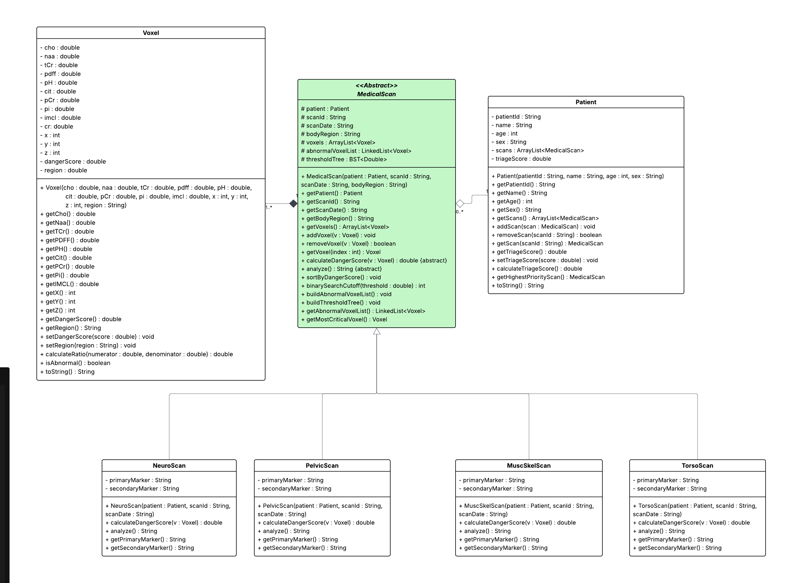

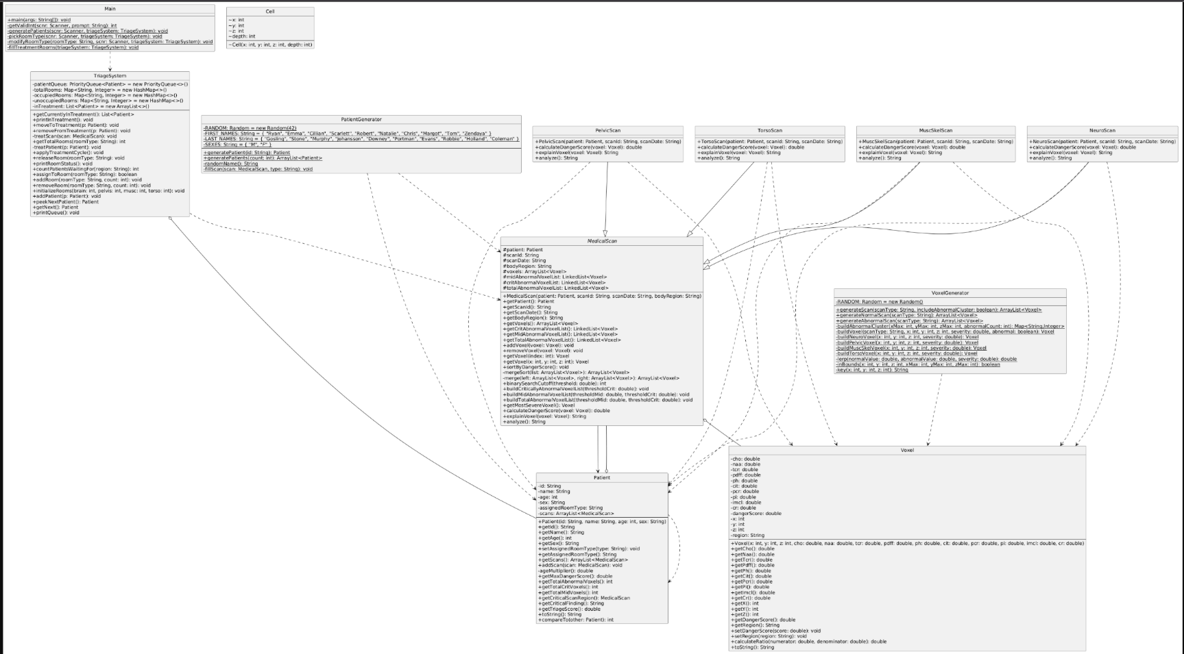
Final UML Diagram (Generated using UML Generator for Java):
*Sorry you might have to zoom in*
(Obviously extremely messy – I got way too far ahead of myself when building the relationships between classes, so I think there are lots of areas that I could improve this program structurally – particularly through proper usage of composition)

Table I used for my biochemical ratios to detect abnormalities (found research, put into ChatGPT to synthesize information into table format, manually verified ratios were correct based on research):
